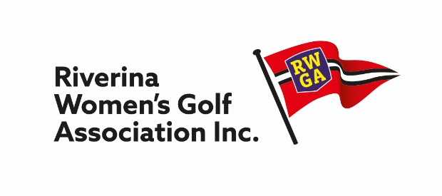

President Secretary
Trish Gray Judy Kroek
42 Condon Avenue 3 Fox Street
Wagga Wagga, NSW. 2650 Wagga Wagga NSW 2650
Mobile: O401312201 Mobile: 0407973170
trish44@bigpond.net.au secretary@rwga.org.au

RUDD ALLEN TROPHY

BEST 3 SCRATCH SCORES & BEST 3 NETT SCORES

18 hole stroke play competition.

To be played on any Club competition day from 1st May till July 31st.

Players enter their club competition as an individual player.

Clubs may enter in one or both categories.

Scores are eligible for Gross and/or Nett.

Lady golfers, members of more than one RWGA club, may enter at each club.

Entry fee is $20.00 per club. (Both Scratch and Nett teams included)

Entries close Friday 31st July 2021

Entries to be received by Co-ordinator by August 12th

Entry Fee by direct deposit to:
Bendigo Bank
BSB: 633000
Account Number: 153056866
Account Name: Riverina Ladies Golf Association Inc
Essential to include identification when depositing money.
Reference with Clubname RuddAllen

Coordinator

Sandy Newton
Email: gandsnewton@bigpond.com
Ph: 0418 457 600

