RWGA
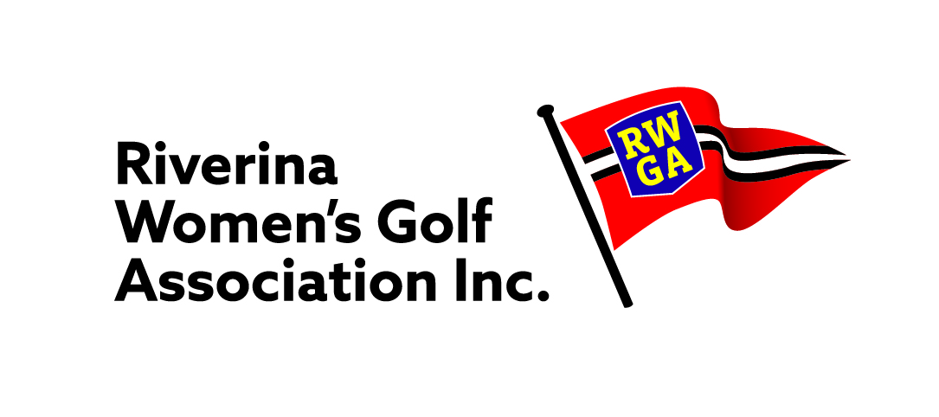
"0VER 80’s"
"BERYL KENNEDY MEMORIAL TROPHY"

Conditions of play are ~
- All players that are 80 & 80+ as from 1st January are eligible to enter.
- Played between 1st March through to the 31st July
- 18 hole Stroke competitions played at Club level only.
- All Scratch and Nett scores played, recorded.
- No extra cost to enter

NAME | Golflink No | GA | Scratch | Nett | NAME | Golflink No | GA | Nett | Scratch

- CLUB: _________________________________________________________ Date Played:

- BEST SCRATCH SCORE = ___________ _________________________________ (Record Name and score)

- BEST NETT SCORE = ___________ _______________________________ (Record Name and score)

- A Player can win either Scratch or Nett Event, one player, one prize.

Winners names and scores to be sent through to Christine Cunial dcu53417@bigpond.net.au

Beryl Kennedy Winners will be presented with their Trophy and Voucher at their Home Club by an RWGA Executive member.
Entries must be lodged with the Co-Ordinator by 12th August

