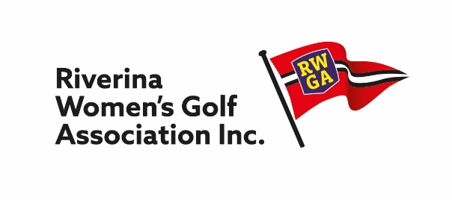

PRESIDENT’S REPORT

What a year! 2020 sounded so positive – the start of a new decade! What a let down!

I and many others enjoyed the Ladies Tournament at Narrandera in early March. Even then it was becoming more obvious that COVID had the potential to spoil our golf season but with no cases reported in the Riverina area we held our District Meeting in late March. It was very clear by then that our Season was going to be like no other: Pennant was cancelled, Club tournaments were cancelled, our Sand Green and Foursome Championships were cancelled and, finally, in June/July, the Open Championship was cancelled – all very sad indeed – our yearly “golf catch up/booze up” gone for 2020. The Annual District Meeting was the final victim being postponed until 2021.

In July, the RWGA was saddened to learn of the passing of one of its most enthusiastic supporters: Elvie Jones. Elvie will long be remembered for her attendance at club tournaments – Rest in Peace Elvie.

2020 was a disappointing year not only for COVID reasons but also disappointing with lack of volunteers for positions i.e. Captain, Match Committee.

The Working Party established at the March District Meeting met several times via ZOOM. It also explored with other Districts their current strategy in running their Districts and with GNSW in order to prepare a Corporate Plan 2021 – 2015 for the RWGA. A big Thank You goes to the Working Party with special thanks to Kaye Dalton for her expertise in this area – very much appreciated.

There has been a lot of rumors re the Association being split now that the “River” Clubs have affiliated with GNSW. To date, only Rich River has affiliated with the RWGA and we welcome them. The other river clubs i.e., Yarrawonga, Murray Downs etc., are yet to affiliate. The affiliation of all these clubs certainly does raise issues regarding the ‘size’ of the RWGA and the various difficulties associated with a large District, i.e., participation in District Championship events, Club tournaments, Pennant – ‘difficulties’ which can be solved if “we” approach them with an open and unbiased mind.

I most sincerely Thank the Executive Committee and the Match Committee for their efforts this year – not easy but you did it. Thank You. And to our retiring Treasurer, Kathleen Williams, a very Special Thank You for your excellent “Book Keeping” skills. I am sure the incoming Treasurer will appreciate your management skills in keeping clear and concise records.

So on to 2021 – may a large amount of normality reappear for our Golfing Season.

Trish Gray
President
5 February 2021

