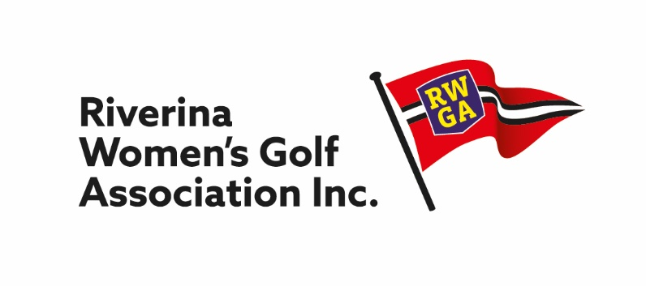

CHAIR, MATCH COMMITTEE REPORT

2020 was off to a sad start – no volunteer for the Captain’s position!

The Match Committee met and determined that it would run golf as a “team” and that the President would Chair the meetings for the first 6 months. Unfortunately, with the pandemic taking hold all golfing activities were cancelled in 2020 – let’s hope 2021 will be more successful.

Thank you to the Match Committee members who accepted their nomination to serve – I hope that you will all stand again and be able to learn a lot more about the running of golf in 2021. Big Thank You to Alison Campbell for accepting the Committee’s invitation to fill the vacancy on the Match Committee.

The Match Committee looks forward to a busy 2021 Golfing Season.

Trish Gray
Chair, Match Committee
5 February 2021

