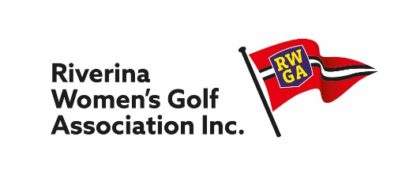
President Secretary
Trish Gray Kathy Simpson
42 Condon Avenue 161 Faulkner Street
Wagga Wagga, NSW. 2650 DENILIQUIN NSW 2710
Mobile: O401312201 Mobile: 0488229637
trish44@bigpond.net.au secretary@riverinalga.com.au RWGA v SWLGA

Nominations are invited from players available to represent RWGA on
Monday 7th June 2021 to play the South West Ladies Golf Association team
at Commercial Albury Golf Club.

The following divisional GA handicap ranges will apply:
- Division 1 - Handicap 0 – 18
- Division 2 - Handicap 19 – 23

Nominations must be with the Secretary by Friday, 30 April for consideration at Match Committee meeting in May when the 2021 squad selection will be finalised.
The selected players and reserves will be advised in the following week.

Please return forms to: Trish Gray, Chairperson, Match Committee

trish44@bigpond.net.au

CLUB NAME: ________________________________

CLUB CONTACT: _____________________________ Mobile No. ______________________

Name | GolfLink No. | H/cap | Mobile No | Email

