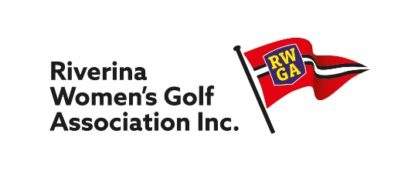
President Secretary
Trish Gray Judy Kroek
42 Condon Avenue 3 Fox Street
Wagga Wagga, NSW. 2650 WAGGA WAGGA NSW 2650
Mobile: O401312201 Mobile: 0407973170
trish44@bigpond.net.au secretary@rwga.com.au

RWGA v SWLGA

Nominations are invited from players available to represent RWGA on
Monday 6th June 2022 to play the South West Ladies Golf Association team
at Young Golf Club

The following divisional GA handicap ranges will apply:
- Division 1 - Handicap 0 – 18.9
- Division 2 - Handicap 19 onwards

Nominations must be with the Secretary by Friday, 29 April for consideration at Match Committee meeting on 1 May when the 2022 squad selection will be finalized. The selected players and reserves will be advised in the following week.

CLUB NAME: ________________________________

CLUB CONTACT: _____________________________ Mobile No. ______________________

Name | GolfLink No. | GA H/cap | Mobile No | Email

