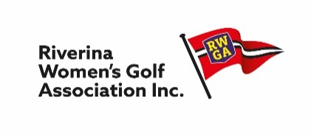Rudd Allen Trophy Result Sheet
Rudd Allen is a Closed Event
Email a copy of winning cards showing Scratch Score on the day of play and Scratch Rating.
SEND ENTRIES TO:
Sandy Newton
Email: gandsnewton@bigpond.com
Ph: 0418 457 600

 | Club Name:
 | Scratch Scores
Name + GolfLink Number |  |  | Score |  | Scratch Rating | Result (Scratch score – Scratch Rating)
1
2
3
Eg Mary May |  |  | 80 |  | 73 | 80-73 = +6
 |  |  | Total Score
 | Handicap Scores
Name + GolfLink Number |  | Scratch | Daily H/Cap | Nett | Par | Result (Nett – Par)
1
2
3
Eg Mary May |  | 80 | 10 | 70 | 72 | 70-72 = -2

Bendigo Bank
BSB: 633000
Account Number: 153056866
Account Name: Riverina Ladies Golf Association Inc
Essential to include identification when depositing money.
Reference with Clubname RuddAllen

